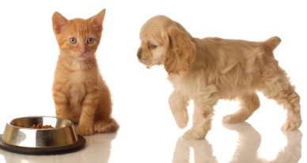PetStayInn C:\Users\mickey\AppData\Local\Microsoft\Windows\Temporary Internet Files\Low\Content.IE5\OBHY3W58\MC900367342[1].WMF

**(In home pet boarding)** **Address: Mechanicsville, VA 23111**

**E-Mail:** [**PetStayInn@yahoo.com**](mailto:PetStayInn@yahoo.com)

Website: **PetStayInn.weebly.com**

**Hours: 9:00 a.m. – 6:00 p.m. M-F**

**Saturday & Sunday Drop Off 3:00 p.m.**

**Saturday Pick Up 12:00 p.m. to 6:00 p.m.**

**Sunday Pick Up 2:00 p.m. to 6:00 p.m.**

***Boarding Check- In / Medical Authorization Consent Form***

Your Name: _____________________________________ Your Pet’s Name(s): _____________________________________

_____________________________________________________________________________________________________

Contact Phone Numbers While You Are Away: ________________________________________________________________

Emergency Contact Person(s) / Phone Number(s): _____________________________________________________________

______________________________________________________________________________________________________

Duration of Pet’s Stay with Us - Drop off Date: ______________ Pick up Date: ______________

Will someone other than yourself be picking up your pet? ________ If so, Please give their name and phone number:

Name: __________________________________________ Phone Number: _____________________________________

Are any of your pets on any medications that we will need to give while they are staying here with us? ____________

If so, please list below, the **pet’s name**, the **name of the medication**, the **dosage**, and **how often it is given** during the day.

Please **include prescription foods** as well, including **the amount and how often fed**. Please DO NOT use medical short hand

when writing medication directions.

___________________________________________________________________________________________________________________________________________________________________________________________________________________________________________________________________________________________________________________________________________________________________________________________________________________

Please note any other special instructions below:

_____________________________________________________________________________________________________________________________________________________________________________________________________________________________________________________________________________________________________________

In respect for your pet, I will transport your pet/pets to the closest and available animal hospital to receive supportive care deemed necessary in the event your pet/pets becomes ill during his/ her stay. We will attempt to contact you and/ or your emergency contact listed above before any treatment is given, however, in the event we cannot contact you or the emergency contact, your signature below authorizes the doctors and staff at the animal hospital I have transported your pet (s) too, to provide minimal supportive care until contact can be made. Any treatment and/ or medication cost for this care are the responsibility of the pet owner.

Sign: ___________________________________________ Date: _______________________________